**Splunk Universal Forwarder**

A universal forwarder collects data from a variety of places — whether data sources or other forwarders — and then sends it to a forwarder or a Splunk deployment. So, what can you do with universal forwarders? Capabilities include:

Tagging metadata (source, source type and host)

Configuring buffering

Compressing data

Securing via SSL

Using any available network ports

**Steps to  integrate splunk .pem files data into new relic**

1. Firstly to get splunk .pem files in your system, Go to splunk universal forwarder

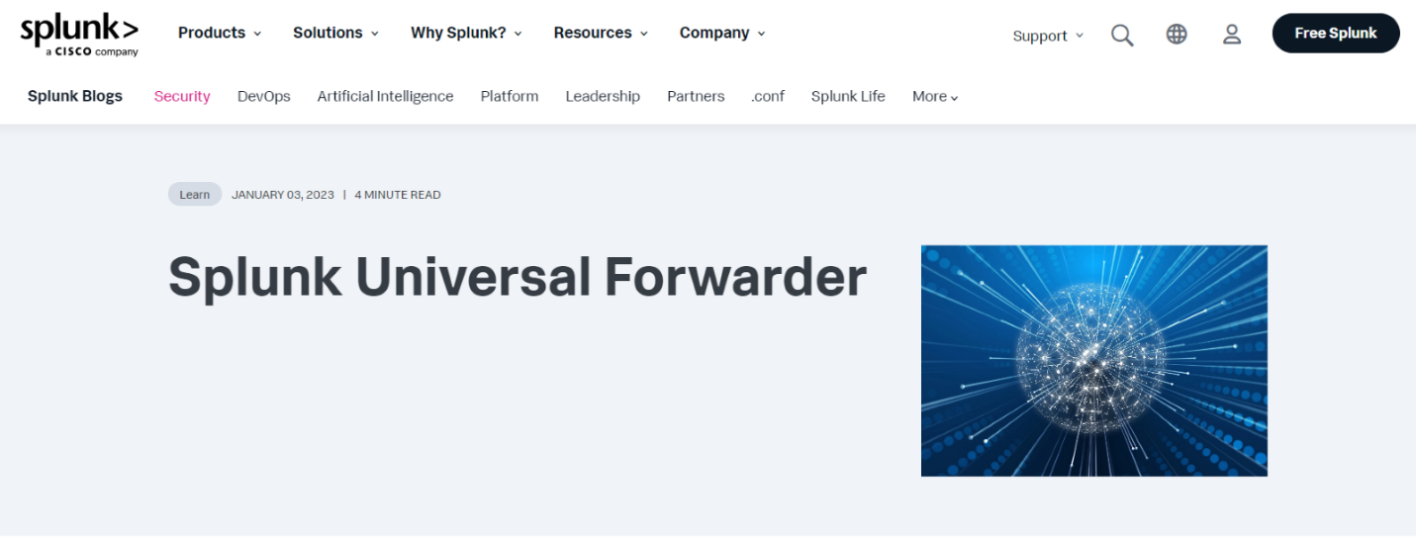

Click on Free splunk At the Top Right

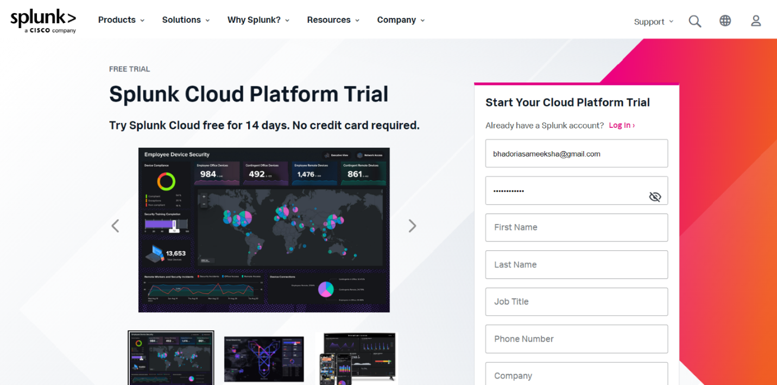

Now give your email and the required details for moving further.

You will get the verification link and then login to splunk universal forwarder. After logging in, you will have an access to download also select according to your windows version. And click on download now .

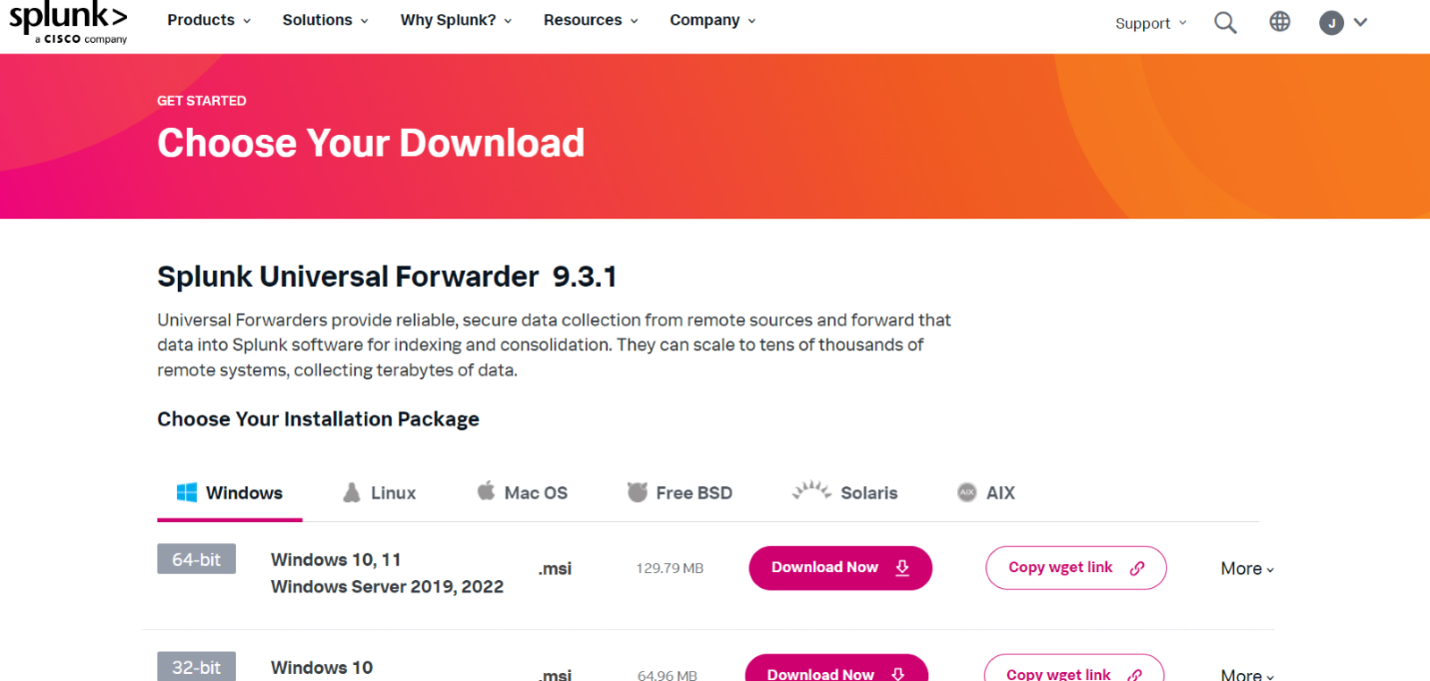

After downloading Go to local disk C> Program Files >SplunkUniversalForwarder>etc>auth

You will be able to access .pem files .

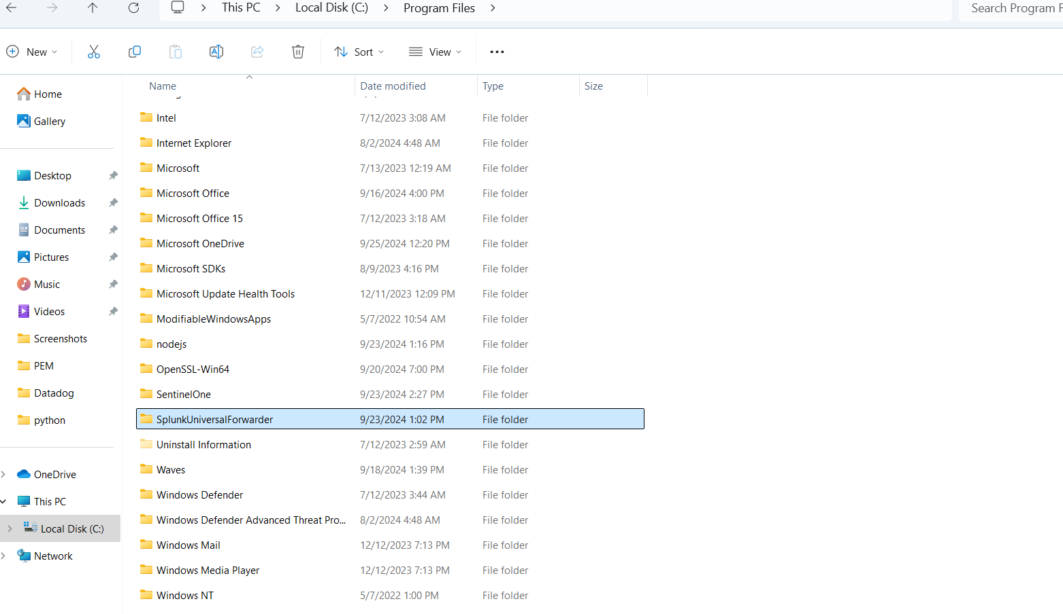

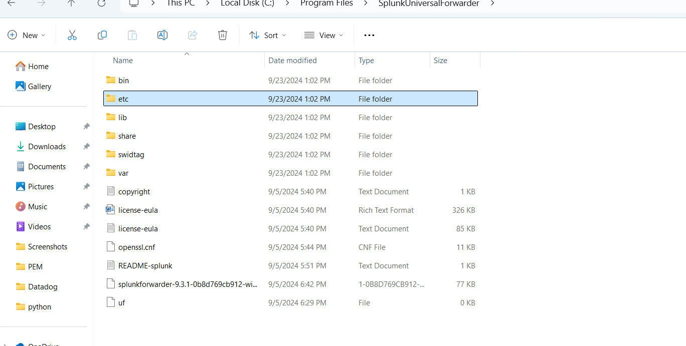

**To integrate a pem file like server.pem with the New Relic , firstly we will write a code in js to convert it into a json format and after that we will push it to the New Relic through flex integration in New Relic Agent.**

**In the pemFilePath we will give the server.pem file path so that it will be changed to json format and we will run this js folder like (node converPemToJson.js) and the json folder will be downloaded. Using this code it will be downloaded in our laptop automatically as we had given outputFilePath for that(certificate.json) . After getting it in json format we will use flex integration in New Relic Agent folder to push it to New Relic.**

New Relic Agent Folder –

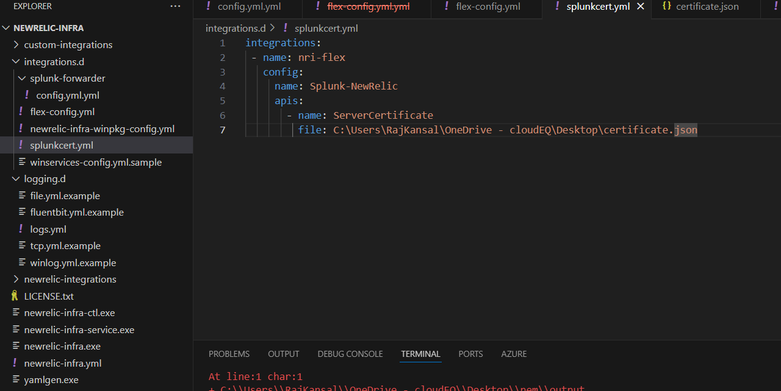

**In this folder we had given path for that json file and pushed it to New Relic through flex integration**.

Data has been shown like that –

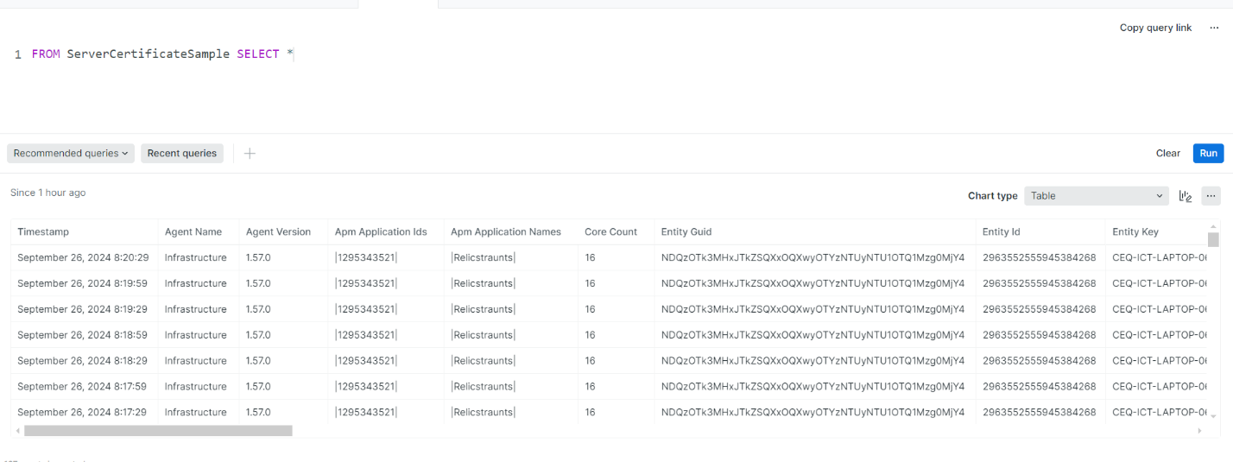

**Now , there is validFrom and validTo key value pair in the json file which is showing that this universal forwarder is valid from this date upto that date. If we want to see the remaining time of validation from the current timestamp we will have to get validToTimestamp for that in epoch format , because New Relic time is in epoch format so we have to minus these two timestamps to get the remaining month and days pending. We already have validToTimestamp in epoch format after making changes in the code so now we just we have to write the query for that.**

